# Bài tập thực hành

Lê Quốc Huy _số máy 15

## Bài 1 Truyện cười

### Bước 1: Tạo layout cho activity_main.xml

<?xml version="1.0" encoding="utf-8"?>

<LinearLayout xmlns:android="http://schemas.android.com/apk/res/android"

android:id="@+id/ln_main"

android:layout_width="match_parent"

android:layout_height="match_parent"

android:orientation="horizontal">

</LinearLayout>

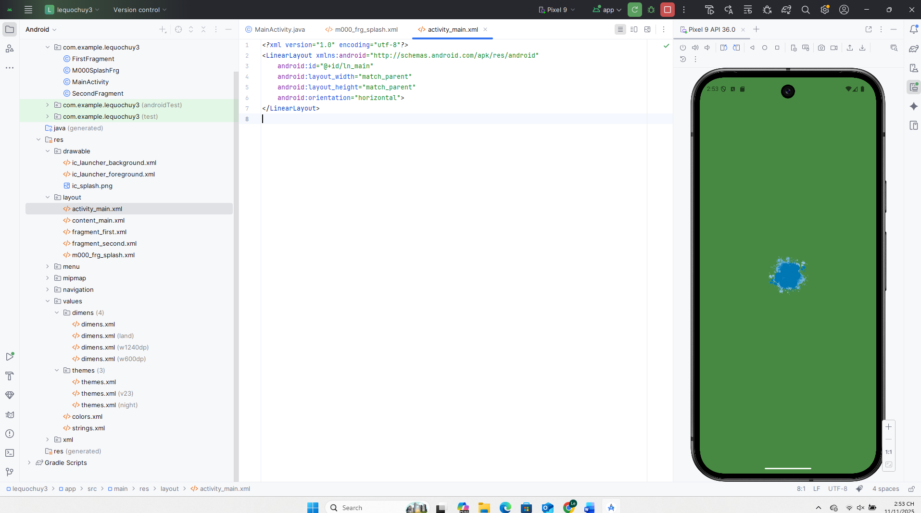

### Bước 2: Tạo m000_frg_splash.xml

<?xml version="1.0" encoding="utf-8"?>

<FrameLayout xmlns:android="http://schemas.android.com/apk/res/android"

android:layout_width="match_parent"

android:layout_height="match_parent"

android:background="@color/greenMid">

<ImageView

android:layout_width="200dp"

android:layout_height="100dp"

android:layout_gravity="center"

android:src="@mipmap/ic_launcher" />

### Bước 3: Tạo layout cho m001_frg_story_list.xml

<?xml version="1.0" encoding="utf-8"?>

<LinearLayout xmlns:android="http://schemas.android.com/apk/res/android"

android:layout_width="match_parent"

android:layout_height="match_parent"

android:orientation="vertical"

android:background="@color/greenSuperLight">

<TextView

android:id="@+id/tvTitle"

android:layout_width="match_parent"

android:layout_height="50dp"

android:gravity="center_vertical"

android:paddingStart="16dp"

android:text="TRUYỆN CƯỜI"

android:textSize="20sp"

android:textStyle="bold"

android:background="@color/greenMid"

android:textColor="@color/white" />

<ListView

android:id="@+id/lvStory"

android:layout_width="match_parent"

android:layout_height="0dp"

android:layout_weight="1"

android:dividerHeight="1dp" />

</LinearLayout>

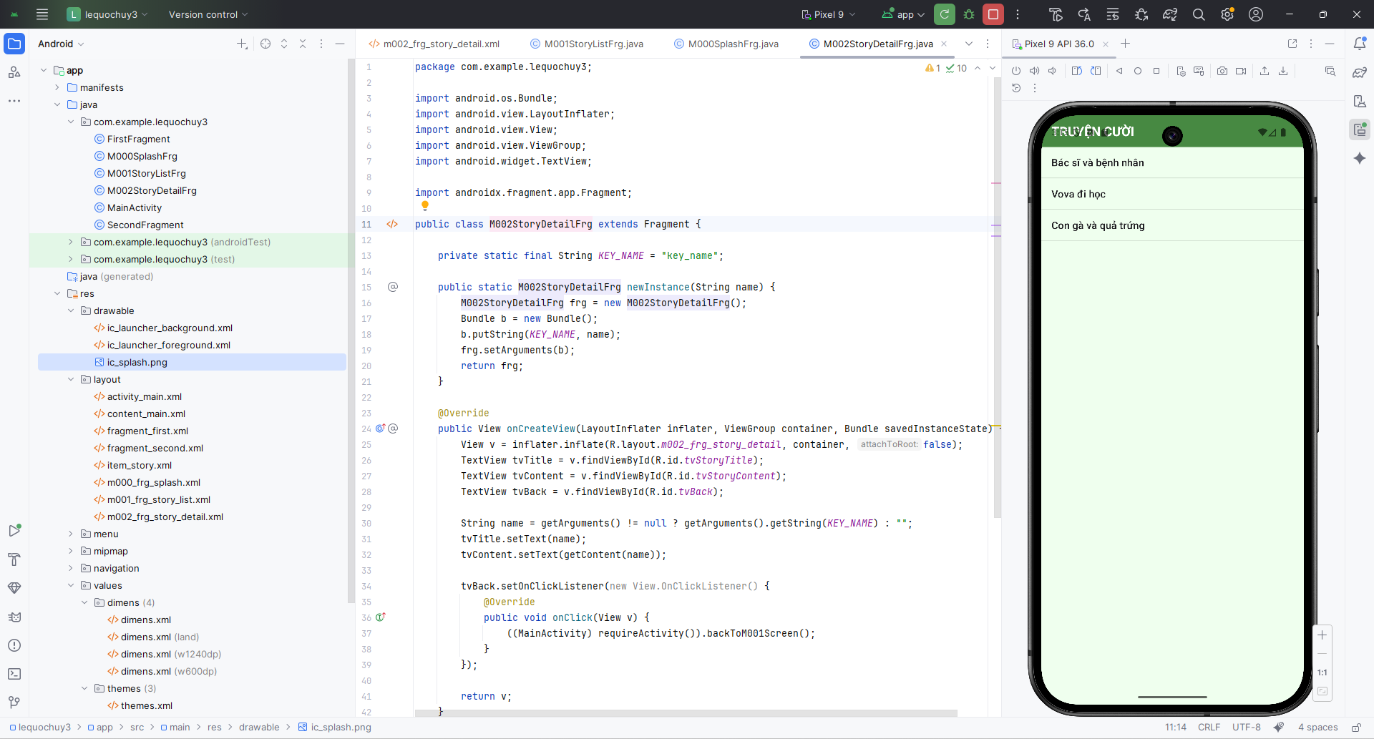

### Bước 4: Tạo layout cho m002_frg_story_detail.xml

*<?*xml version="1.0" encoding="utf-8"*?>*<LinearLayout xmlns:android="http://schemas.android.com/apk/res/android"  
 android:layout_width="match_parent"  
 android:layout_height="match_parent"  
 android:orientation="vertical"  
 android:background="@color/greenSuperLight">  
  
 <LinearLayout  
 android:layout_width="match_parent"  
 android:layout_height="50dp"  
 android:orientation="horizontal"  
 android:background="@color/greenMid">  
  
 <TextView  
 android:id="@+id/tvBack"  
 android:layout_width="50dp"  
 android:layout_height="match_parent"  
 android:gravity="center"  
 android:text="&lt;"  
 android:textSize="20sp"  
 android:textColor="@color/white" />  
  
 <TextView  
 android:id="@+id/tvStoryTitle"  
 android:layout_width="0dp"  
 android:layout_height="match_parent"  
 android:layout_weight="1"  
 android:gravity="center_vertical"  
 android:text="Tên truyện"  
 android:textSize="18sp"  
 android:textStyle="bold"  
 android:textColor="@color/white" />  
 </LinearLayout>  
  
 <ScrollView  
 android:layout_width="match_parent"  
 android:layout_height="0dp"  
 android:layout_weight="1"  
 android:padding="16dp">  
  
 <TextView  
 android:id="@+id/tvStoryContent"  
 android:layout_width="match_parent"  
 android:layout_height="wrap_content"  
 android:textSize="16sp"  
 android:textColor="@color/black" />  
 </ScrollView>  
</LinearLayout>

### Bước 5: Tạo layout cho item_story

*<?*xml version="1.0" encoding="utf-8"*?>*<androidx.constraintlayout.widget.ConstraintLayout xmlns:android="http://schemas.android.com/apk/res/android"  
 android:layout_width="match_parent"  
 android:layout_height="match_parent">  
</androidx.constraintlayout.widget.ConstraintLayout>

### Bước 6: Tạo M000SplashFrg.java

package com.example.lequochuy3;  
  
import android.os.Bundle;  
import android.os.Handler;  
import android.view.LayoutInflater;  
import android.view.View;  
import android.view.ViewGroup;  
  
import androidx.fragment.app.Fragment;  
  
public class M000SplashFrg extends Fragment {  
  
 @Override  
 public View onCreateView(LayoutInflater inflater, ViewGroup container, Bundle savedInstanceState) {  
 View v = inflater.inflate(R.layout.*m000_frg_splash*, container, false);  
 initViews();  
 return v;  
 }  
  
 private void initViews() {  
 new Handler().postDelayed(this::gotoM001Screen, 2000);  
 }  
  
 private void gotoM001Screen() {  
 ((MainActivity) requireActivity()).gotoM001Screen();  
 }  
}

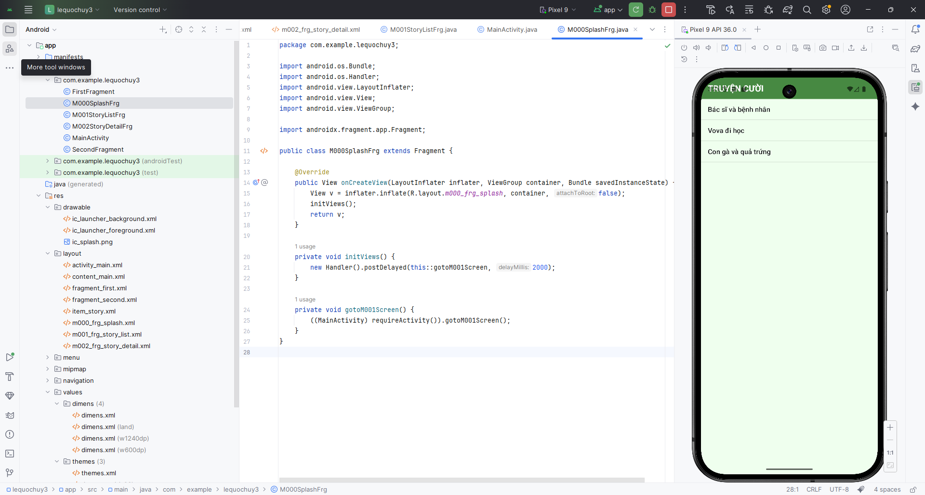

### Bước 7: Tạo M001StoryListFrg.java

package com.example.lequochuy3;  
import android.os.Bundle;  
import android.view.LayoutInflater;  
import android.view.View;  
import android.view.ViewGroup;  
import android.widget.AdapterView;  
import android.widget.ArrayAdapter;  
import android.widget.ListView;  
  
import androidx.fragment.app.Fragment;  
  
public class M001StoryListFrg extends Fragment {  
  
 private String[] names = {  
 "Bác sĩ và bệnh nhân",  
 "Vova đi học",  
 "Con gà và quả trứng"  
 };  
  
 @Override  
 public View onCreateView(LayoutInflater inflater, ViewGroup container, Bundle savedInstanceState) {  
 View v = inflater.inflate(R.layout.*m001_frg_story_list*, container, false);  
 ListView lv = v.findViewById(R.id.*lvStory*);  
  
 ArrayAdapter<String> adapter =  
 new ArrayAdapter<>(requireContext(), android.R.layout.*simple_list_item_1*, names);  
  
 lv.setAdapter(adapter);  
  
 lv.setOnItemClickListener(new AdapterView.OnItemClickListener() {  
 @Override  
 public void onItemClick(AdapterView<?> parent, View view, int position, long id) {  
 ((MainActivity) requireActivity()).gotoM002Screen(names[position]);  
 }  
 });  
  
 return v;  
 }  
}

### Bước 8: Tạo M002StoryDetailFrg.java

package com.example.lequochuy3;  
  
import android.os.Bundle;  
import android.view.LayoutInflater;  
import android.view.View;  
import android.view.ViewGroup;  
import android.widget.AdapterView;  
import android.widget.ArrayAdapter;  
import android.widget.ListView;  
  
import androidx.fragment.app.Fragment;  
  
public class M001StoryListFrg extends Fragment {  
  
 private String[] names = {  
 "Bác sĩ và bệnh nhân",  
 "Vova đi học",  
 "Con gà và quả trứng"  
 };  
  
 @Override  
 public View onCreateView(LayoutInflater inflater, ViewGroup container, Bundle savedInstanceState) {  
 View v = inflater.inflate(R.layout.*m001_frg_story_list*, container, false);  
 ListView lv = v.findViewById(R.id.*lvStory*);  
  
 ArrayAdapter<String> adapter =  
 new ArrayAdapter<>(requireContext(), android.R.layout.*simple_list_item_1*, names);  
  
 lv.setAdapter(adapter);  
  
 lv.setOnItemClickListener(new AdapterView.OnItemClickListener() {  
 @Override  
 public void onItemClick(AdapterView<?> parent, View view, int position, long id) {  
 ((MainActivity) requireActivity()).gotoM002Screen(names[position]);  
 }  
 });  
  
 return v;  
 }  
}

### Bước 9 Thêm colors.xml

<resources>  
 <color name="purple_200">#FFBB86FC</color>  
 <color name="purple_500">#FF6200EE</color>  
 <color name="purple_700">#FF3700B3</color>  
 <color name="teal_200">#FF03DAC5</color>  
 <color name="teal_700">#FF018786</color>  
 <color name="black">#FF000000</color>  
 <color name="white">#FFFFFFFF</color>  
 <color name="greenMid">#478942</color>  
 <color name="greenLight">#62BC5B</color>  
 <color name="greenSuperLight">#EFFFEE</color>  
</resources>

### A screenshot of a computer code AI-generated content may be incorrect. Bước 10: Thêm themes.xml

Bước 11: Thêm các ic_back ic_face

## Bài 2 Tạo giao diện chức nǎng theo ngôn ngữ máy

### Bước 1: Tạo layout cho m003_act_detail.xml

*<?*xml version="1.0" encoding="utf-8"*?>*<LinearLayout xmlns:android="http://schemas.android.com/apk/res/android"  
 xmlns:app="http://schemas.android.com/apk/res-auto"  
 xmlns:tools="http://schemas.android.com/tools"  
 android:layout_width="match_parent"  
 android:layout_height="match_parent"  
 android:orientation="vertical"  
 android:padding="10dp">  
  
 <TableRow  
 android:layout_width="match_parent"  
 android:layout_height="wrap_content"  
 android:layout_marginHorizontal="10dp"  
 android:layout_marginTop="10dp">  
  
 <TextView  
 android:id="@+id/tv_animal_name"  
 android:layout_width="wrap_content"  
 android:layout_height="wrap_content"  
 android:background="@drawable/bg_radius"  
 android:paddingHorizontal="20dp"  
 android:text="@string/txt_name"  
 android:textColor="@color/white"  
 android:textSize="34sp"  
 android:fontFamily="sans-serif-light" />  
  
 <View  
 android:layout_width="0dp"  
 android:layout_height="match_parent"  
 android:layout_weight="1" />  
  
 <ImageView  
 android:id="@+id/iv_favorite"  
 android:layout_width="40dp"  
 android:layout_height="match_parent"  
 android:src="@drawable/ic_heart_empty"  
 app:tint="#FF0000"  
 tools:ignore="ContentDescription" />  
 </TableRow>  
  
 <ScrollView  
 android:layout_width="match_parent"  
 android:layout_height="300dp"  
 android:layout_marginBottom="10dp">  
  
 <LinearLayout  
 android:layout_width="match_parent"  
 android:layout_height="wrap_content"  
 android:orientation="vertical">  
  
 <TextView  
 android:id="@+id/tv_animal_desc"  
 android:layout_width="match_parent"  
 android:layout_height="wrap_content"  
 android:padding="10dp"  
 android:text="@string/txt_desc"  
 android:textColor="@color/black"  
 android:textSize="18sp"  
 android:lineSpacingExtra="5dp"  
 android:fontFamily="sans-serif-light" />  
 </LinearLayout>  
 </ScrollView>  
  
 <ImageView  
 android:id="@+id/iv_animal"  
 android:layout_width="match_parent"  
 android:layout_height="0dp"  
 android:layout_weight="1"  
 android:src="@drawable/bg_rabbit"  
 android:scaleType="centerCrop"  
 tools:ignore="ContentDescription" />  
  
</LinearLayout>

### Bước 2 Tạo bg_radius.xml ic_heart_empty bg rabbit

<?xml version="1.0" encoding="utf-8"?>

<shape xmlns:android="http://schemas.android.com/apk/res/android">

<corners android:radius="30dp" />

<solid android:color="#3700B3" />

</shape>

### Bước 3: Tạo class RabbitActivity

package com.example.lequochuy3;  
  
import android.os.Bundle;  
  
import androidx.appcompat.app.AppCompatActivity;  
  
public class RabbitActivity extends AppCompatActivity {  
 @Override  
 protected void onCreate(Bundle savedInstanceState) {  
 super.onCreate(savedInstanceState);  
 setContentView(R.layout.*m003_act_detail*);  
 }  
}

Bước 4: Thêm vào AndroidManifest.xml

### Kết quả :

## Bài tập 1

### Bước 1: Tạo layout m004_frg_rotate.xml

<?xml version="1.0" encoding="utf-8"?>

<LinearLayout xmlns:android="http://schemas.android.com/apk/res/android"

android:layout_width="match_parent"

android:layout_height="match_parent"

android:orientation="vertical"

android:padding="16dp">

<Button

android:id="@+id/btnOn"

android:layout_width="match_parent"

android:layout_height="wrap_content"

android:text="ON xoay màn hình" />

<Button

android:id="@+id/btnOff"

android:layout_width="match_parent"

android:layout_height="wrap_content"

android:layout_marginTop="12dp"

android:text="OFF không cho xoay" />

</LinearLayout>

### Bước 2: Tạo class M004RotateFrg.java

package com.example.lequochuy3;  
  
import android.content.pm.ActivityInfo;  
import android.os.Bundle;  
import android.view.LayoutInflater;  
import android.view.View;  
import android.view.ViewGroup;  
import android.widget.Button;  
  
import androidx.fragment.app.Fragment;  
  
public class M004RotateFrg extends Fragment {  
  
 @Override  
 public View onCreateView(LayoutInflater inflater, ViewGroup container, Bundle savedInstanceState) {  
 View v = inflater.inflate(R.layout.*m004_frg_rotate*, container, false);  
 Button btnOn = v.findViewById(R.id.*btnOn*);  
 Button btnOff = v.findViewById(R.id.*btnOff*);  
  
 btnOn.setOnClickListener(new View.OnClickListener() {  
 @Override  
 public void onClick(View view) {  
 requireActivity().setRequestedOrientation(ActivityInfo.*SCREEN_ORIENTATION_UNSPECIFIED*);  
 }  
 });  
  
 btnOff.setOnClickListener(new View.OnClickListener() {  
 @Override  
 public void onClick(View view) {  
 requireActivity().setRequestedOrientation(ActivityInfo.*SCREEN_ORIENTATION_PORTRAIT*);  
 }  
 });  
  
 return v;  
 }  
}

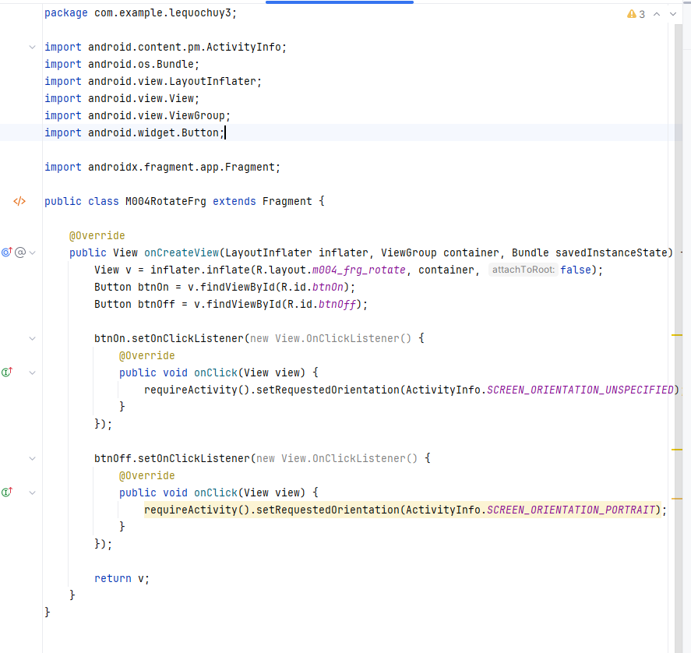

### Bước 3: chỉnh trong RabbitActivity

package com.example.lequochuy3;  
  
import android.content.pm.ActivityInfo;  
import android.os.Bundle;  
import android.widget.Button;  
  
import androidx.appcompat.app.AppCompatActivity;  
  
public class RabbitActivity extends AppCompatActivity {  
 @Override  
 protected void onCreate(Bundle savedInstanceState) {  
 super.onCreate(savedInstanceState);  
 setContentView(R.layout.*m003_act_detail*);  
  
 Button btnOn = findViewById(R.id.*btnOn*);  
 Button btnOff = findViewById(R.id.*btnOff*);  
  
 btnOn.setOnClickListener(v ->  
 setRequestedOrientation(ActivityInfo.*SCREEN_ORIENTATION_UNSPECIFIED*));  
  
 btnOff.setOnClickListener(v ->  
 setRequestedOrientation(ActivityInfo.*SCREEN_ORIENTATION_PORTRAIT*));  
 }  
}

### Kết quả:

## Bài tập 2

### Bước 1: Tạo layout activity_multi_lang.xml

<?xml version="1.0" encoding="utf-8"?>

<LinearLayout xmlns:android="http://schemas.android.com/apk/res/android"

android:layout_width="match_parent"

android:layout_height="match_parent"

android:orientation="vertical"

android:background="#1D2A6B"

android:padding="16dp">

<TextView

android:id="@+id/tvTitle"

android:layout_width="match_parent"

android:layout_height="wrap_content"

android:text="@string/title"

android:textSize="28sp"

android:textStyle="bold"

android:textColor="@android:color/white"

android:gravity="center"

android:layout_marginTop="40dp"

android:layout_marginBottom="40dp" />

<TextView

android:id="@+id/tvEmailLabel"

android:layout_width="match_parent"

android:layout_height="wrap_content"

android:text="@string/email"

android:textColor="@android:color/white" />

<EditText

android:id="@+id/edtEmail"

android:layout_width="match_parent"

android:layout_height="wrap_content"

android:background="@android:color/transparent"

android:textColor="@android:color/white" />

<View

android:layout_width="match_parent"

android:layout_height="1dp"

android:background="@android:color/white"

android:layout_marginBottom="20dp" />

<TextView

android:id="@+id/tvPassLabel"

android:layout_width="match_parent"

android:layout_height="wrap_content"

android:text="@string/password"

android:textColor="@android:color/white" />

<EditText

android:id="@+id/edtPass"

android:layout_width="match_parent"

android:layout_height="wrap_content"

android:background="@android:color/transparent"

android:textColor="@android:color/white" />

<View

android:layout_width="match_parent"

android:layout_height="1dp"

android:background="@android:color/white"

android:layout_marginBottom="20dp" />

<Button

android:id="@+id/btnLogin"

android:layout_width="match_parent"

android:layout_height="wrap_content"

android:text="@string/login" />

<TextView

android:id="@+id/tvNoAccount"

android:layout_width="match_parent"

android:layout_height="wrap_content"

android:text="@string/no_account"

android:textColor="@android:color/white"

android:gravity="center"

android:layout_marginTop="20dp"

android:layout_marginBottom="30dp" />

<LinearLayout

android:layout_width="match_parent"

android:layout_height="wrap_content"

android:orientation="horizontal"

android:gravity="center">

<TextView

android:id="@+id/tvVi"

android:layout_width="wrap_content"

android:layout_height="wrap_content"

android:text="Tiếng Việt"

android:textColor="@android:color/white"

android:padding="8dp" />

<TextView

android:id="@+id/tvEn"

android:layout_width="wrap_content"

android:layout_height="wrap_content"

android:text="English"

android:textColor="@android:color/white"

android:padding="8dp" />

<TextView

android:id="@+id/tvFr"

android:layout_width="wrap_content"

android:layout_height="wrap_content"

android:text="Français"

android:textColor="@android:color/white"

android:padding="8dp" />

</LinearLayout>

</LinearLayout>

### Bước 2: Tạo layout menu_language.xml

<menu xmlns:android="http://schemas.android.com/apk/res/android"  
 xmlns:app="http://schemas.android.com/apk/res-auto"  
 xmlns:tools="http://schemas.android.com/tools"  
 tools:context="com.example.lequochuy3.MainActivity">  
 <item  
 android:id="@+id/action_settings"  
 android:orderInCategory="100"  
 android:title="@string/action_settings"  
 app:showAsAction="never" />  
</menu>

### Bước 3: Tạo class MultiLangActivity.java

package com.example.lequochuy3;

import android.content.Intent;

import android.content.res.Configuration;

import android.os.Bundle;

import android.view.Menu;

import android.view.MenuItem;

import android.widget.TextView;

import androidx.appcompat.app.AppCompatActivity;

import java.util.Locale;

public class MultiLangActivity extends AppCompatActivity {

@Override

protected void onCreate(Bundle savedInstanceState) {

super.onCreate(savedInstanceState);

setContentView(R.layout.activity_multi_lang);

TextView tvVi = findViewById(R.id.tvVi);

TextView tvEn = findViewById(R.id.tvEn);

TextView tvFr = findViewById(R.id.tvFr);

tvVi.setOnClickListener(v -> setLocale("vi"));

tvEn.setOnClickListener(v -> setLocale("en"));

tvFr.setOnClickListener(v -> setLocale("fr"));

}

@Override

public boolean onCreateOptionsMenu(Menu menu) {

getMenuInflater().inflate(R.menu.menu_language, menu);

return true;

}

@Override

public boolean onOptionsItemSelected(MenuItem item) {

int id = item.getItemId();

if (id == R.id.mn_vi) {

setLocale("vi");

return true;

} else if (id == R.id.mn_en) {

setLocale("en");

return true;

} else if (id == R.id.mn_fr) {

setLocale("fr");

return true;

}

return super.onOptionsItemSelected(item);

}

private void setLocale(String lang) {

Locale locale = new Locale(lang);

Locale.setDefault(locale);

Configuration config = new Configuration();

config.setLocale(locale);

getResources().updateConfiguration(config, getResources().getDisplayMetrics());

Intent i = new Intent(this, MultiLangActivity.class);

i.setFlags(Intent.FLAG_ACTIVITY_CLEAR_TOP | Intent.FLAG_ACTIVITY_NEW_TASK);

startActivity(i);

finish();

}

}

### Bước 4: AndroidManifest.xml thêm activity

<activity android:name=".MultiLangActivity" />



### Bước 5 Thêm values/strings.xml

<?xml version="1.0" encoding="utf-8"?>

<resources>

<string name="app_name">Multi Language App</string>

<string name="title">Xin chào</string>

<string name="email">Email</string>

<string name="password">Mật khẩu</string>

<string name="login">ĐĂNG NHẬP</string>

<string name="no_account">Không có tài khoản. Vui lòng đăng ký</string>

</resources>

### Bước 6 Thêm values-en/strings.xml

<?xml version="1.0" encoding="utf-8"?>

<resources>

<string name="app_name">Multi Language App</string>

<string name="title">Welcome!</string>

<string name="email">Email Address</string>

<string name="password">Password</string>

<string name="login">LOGIN</string>

<string name="no_account">Don&apos;t have account? Sign Up</string>

</resources>

### Bước 7 values-fr/strings.xml

<?xml version="1.0" encoding="utf-8"?>

<resources>

<string name="app_name">Multi Language App</string>

<string name="title">accueil</string>

<string name="email">adresse e-mail</string>

<string name="password">mot de passe</string>

<string name="login">CONNEXION</string>

<string name="no_account">Ne pas avoir un compte? signer</string>

</resources>

Bước 8 chuyển từ màn M001StoryListFrg.java

package com.example.lequochuy3;

import android.content.Intent;

import android.os.Bundle;

import android.view.LayoutInflater;

import android.view.View;

import android.view.ViewGroup;

import android.widget.AdapterView;

import android.widget.ArrayAdapter;

import android.widget.ListView;

import androidx.fragment.app.Fragment;

public class M001StoryListFrg extends Fragment {

private String[] names = {

"Bác sĩ và bệnh nhân",

"Vova đi học",

"Con gà và quả trứng",

"Xem màn con thỏ",

"Màn đa ngôn ngữ"

};

@Override

public View onCreateView(LayoutInflater inflater, ViewGroup container, Bundle savedInstanceState) {

View v = inflater.inflate(R.layout.m001_frg_story_list, container, false);

ListView lv = v.findViewById(R.id.lvStory);

ArrayAdapter<String> adapter =

new ArrayAdapter<>(requireContext(), android.R.layout.simple_list_item_1, names);

lv.setAdapter(adapter);

lv.setOnItemClickListener(new AdapterView.OnItemClickListener() {

@Override

public void onItemClick(AdapterView<?> parent, View view, int position, long id) {

if (position == 3) {

Intent i = new Intent(requireContext(), RabbitActivity.class);

startActivity(i);

} else if (position == 4) {

Intent i = new Intent(requireContext(), MultiLangActivity.class);

startActivity(i);

} else {

((MainActivity) requireActivity()).gotoM002Screen(names[position]);

}

}

});

return v;

}

}

### Kết quả :

## Bài tập tạo login

### Bước 1 Tạo giao diện activity_login.xml

<?xml version="1.0" encoding="utf-8"?>

<RelativeLayout xmlns:android="http://schemas.android.com/apk/res/android"

android:layout_width="match_parent"

android:layout_height="match_parent"

android:background="#E6DED9">

<LinearLayout

android:id="@+id/header"

android:layout_width="match_parent"

android:layout_height="260dp"

android:background="@drawable/bg_login_header"

android:orientation="vertical"

android:paddingTop="40dp"

android:paddingEnd="24dp"

android:gravity="end|top" >

<TextView

android:id="@+id/tvLogin"

android:layout_width="wrap_content"

android:layout_height="wrap_content"

android:text="Login"

android:textColor="@android:color/white"

android:textSize="18sp" />

</LinearLayout>

<LinearLayout

android:layout_width="match_parent"

android:layout_height="wrap_content"

android:layout_below="@id/header"

android:orientation="vertical"

android:padding="24dp">

<LinearLayout

android:layout_width="match_parent"

android:layout_height="50dp"

android:background="@drawable/bg_input"

android:orientation="horizontal"

android:gravity="center_vertical"

android:paddingStart="14dp"

android:paddingEnd="14dp"

android:layout_marginBottom="14dp">

<ImageView

android:layout_width="20dp"

android:layout_height="20dp"

android:src="@drawable/ic_email"

android:tint="#8C8C8C" />

<EditText

android:id="@+id/edtEmail"

android:layout_width="0dp"

android:layout_height="wrap_content"

android:layout_weight="1"

android:background="@android:color/transparent"

android:hint="Email"

android:paddingStart="12dp"

android:textColor="#000000"

android:textColorHint="#A0A0A0" />

</LinearLayout>

<LinearLayout

android:layout_width="match_parent"

android:layout_height="50dp"

android:background="@drawable/bg_input"

android:orientation="horizontal"

android:gravity="center_vertical"

android:paddingStart="14dp"

android:paddingEnd="14dp">

<ImageView

android:layout_width="20dp"

android:layout_height="20dp"

android:src="@drawable/ic_key"

android:tint="#8C8C8C" />

<EditText

android:id="@+id/edtPass"

android:layout_width="0dp"

android:layout_height="wrap_content"

android:layout_weight="1"

android:background="@android:color/transparent"

android:hint="Password"

android:inputType="textPassword"

android:paddingStart="12dp"

android:textColor="#000000"

android:textColorHint="#A0A0A0" />

</LinearLayout>

<TextView

android:id="@+id/tvForgot"

android:layout_width="wrap_content"

android:layout_height="wrap_content"

android:text="Forgot password?"

android:textColor="#000000"

android:textSize="12sp"

android:layout_gravity="end"

android:layout_marginTop="8dp"

android:layout_marginBottom="20dp" />

<Button

android:id="@+id/btnLogin"

android:layout_width="match_parent"

android:layout_height="50dp"

android:background="@drawable/bg_button_login"

android:text="Login"

android:textColor="@android:color/white"

android:textAllCaps="false"

android:textSize="16sp" />

<LinearLayout

android:layout_width="match_parent"

android:layout_height="wrap_content"

android:layout_marginTop="28dp"

android:orientation="horizontal"

android:gravity="center">

<TextView

android:layout_width="wrap_content"

android:layout_height="wrap_content"

android:text="Don't have an account?"

android:textSize="12sp"

android:textColor="#000000" />

<TextView

android:id="@+id/tvRegister"

android:layout_width="wrap_content"

android:layout_height="wrap_content"

android:text=" Register"

android:textSize="12sp"

android:textColor="#FF8B23" />

</LinearLayout>

</LinearLayout>

</RelativeLayout>

### Bước 2: Tạo bg_login_header.xml bg_input.xml bg_button_login.xml

### Bước 3 tạo class LoginActivity.java

package com.example.lequochuy3;

import android.os.Bundle;

import androidx.appcompat.app.AppCompatActivity;

public class LoginActivity extends AppCompatActivity {

@Override

protected void onCreate(Bundle savedInstanceState) {

super.onCreate(savedInstanceState);

setContentView(R.layout.activity_login);

}

}

### Bước 4 : AndroidManifest.xml thêm



### Bước 5: Chuyển màn từ M001StoryListFrg.java để thêm mục đi tới màn login

package com.example.lequochuy3;

import android.content.Intent;

import android.os.Bundle;

import android.view.LayoutInflater;

import android.view.View;

import android.view.ViewGroup;

import android.widget.AdapterView;

import android.widget.ArrayAdapter;

import android.widget.ListView;

import androidx.fragment.app.Fragment;

public class M001StoryListFrg extends Fragment {

private String[] names = {

"Bác sĩ và bệnh nhân",

"Vova đi học",

"Con gà và quả trứng",

"Xem màn con thỏ",

"Màn đa ngôn ngữ",

"Màn login"

};

@Override

public View onCreateView(LayoutInflater inflater, ViewGroup container, Bundle savedInstanceState) {

View v = inflater.inflate(R.layout.m001_frg_story_list, container, false);

ListView lv = v.findViewById(R.id.lvStory);

ArrayAdapter<String> adapter =

new ArrayAdapter<>(requireContext(), android.R.layout.simple_list_item_1, names);

lv.setAdapter(adapter);

lv.setOnItemClickListener(new AdapterView.OnItemClickListener() {

@Override

public void onItemClick(AdapterView<?> parent, View view, int position, long id) {

if (position == 3) {

startActivity(new Intent(requireContext(), RabbitActivity.class));

} else if (position == 4) {

startActivity(new Intent(requireContext(), MultiLangActivity.class));

} else if (position == 5) {

startActivity(new Intent(requireContext(), LoginActivity.class));

} else {

((MainActivity) requireActivity()).gotoM002Screen(names[position]);

}

}

});

return v;

}

}

### Kết quả

